|  |
| --- |
| Defect Log  UAT: Pass 1  Functional Testing Services for IKANO  August 19, 2014  Version No: V1.0 |

Defect Log

Functional Testing Services for IKANO

DD MMM YYYY

Verinite

Version #.#

-

# Defect Details

|  |  |
| --- | --- |
| **Defect ID** | 0039 |
| **Test Case Description** | In agent interface same type of Holiday List are saved many times. |
| **Expected Result** | Error message should show “Same holiday list will not accept” |
| **Actual Result** | Same lists are displayed |
| **Status** | New |
| **Test data used** | Description : Sunday holidy  Date : 31/08/2014 |
| **Date and Time of test** | 26 Aug 2014 at 12:10 PM (IST) |

**Step 1:**  Login through agent interface

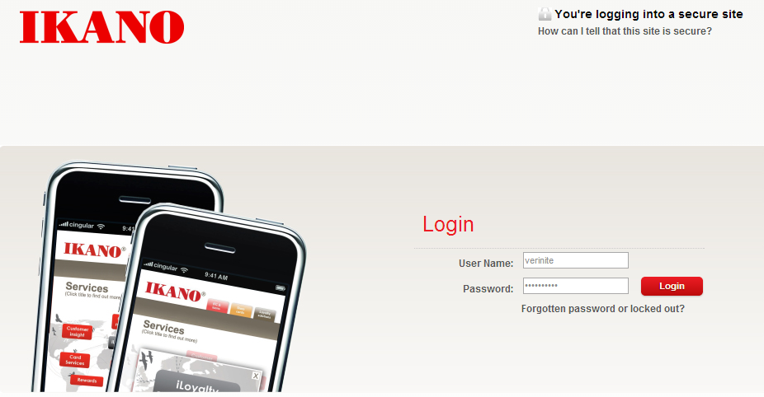

1. **Step 2:**  click on send Times which is given under Service Configuration .

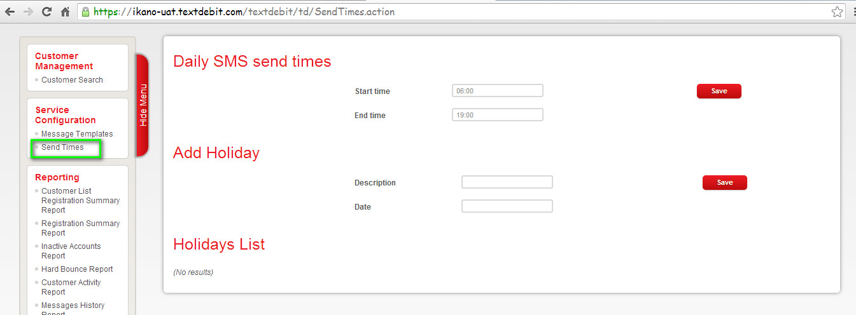

**Step 3:**  Observe holiday description and date in respective feilds.

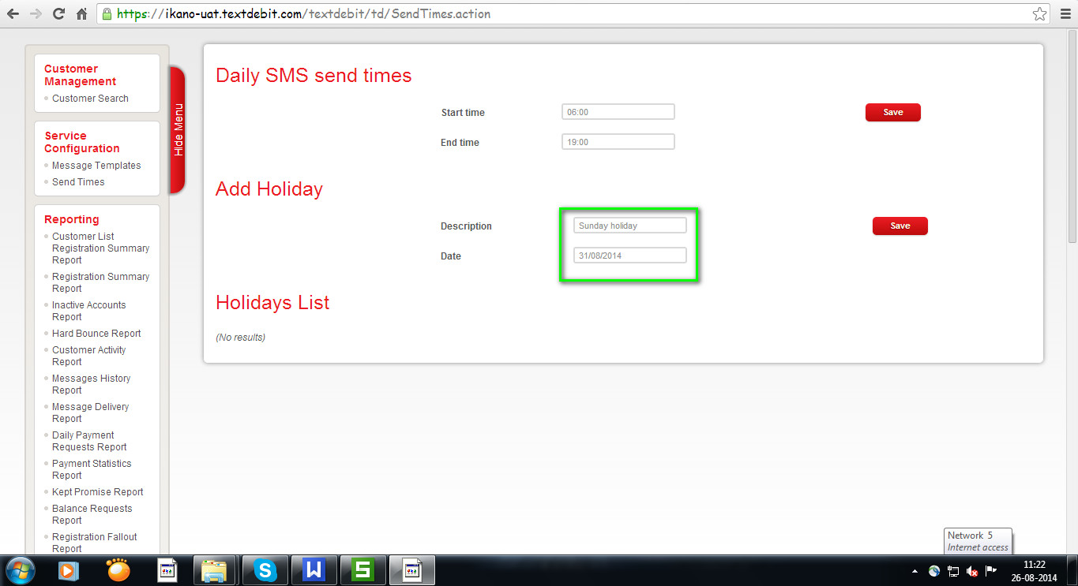

**Step 4.** .Click on Save button.

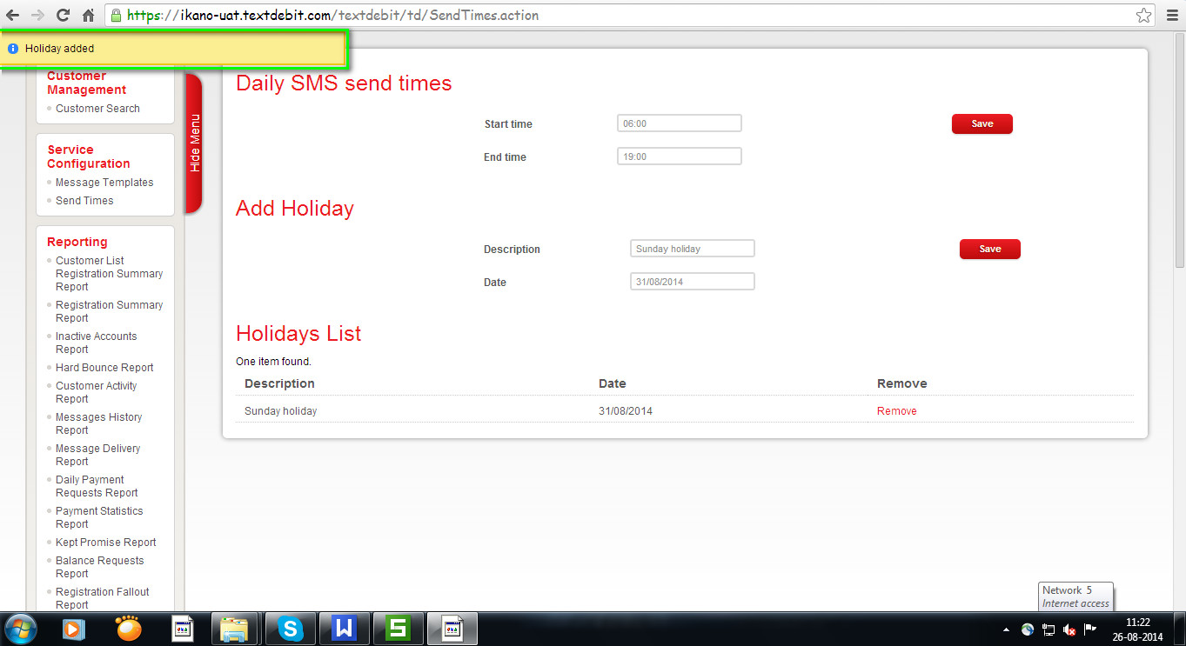

Now observe displayed items it will save same holiday list.

